**First Task: ROS Installation**

Part 1, installing on the VirtualBos – Ubuntu and then jetson nano

Step 1. Install VirtualBox

1. Go to the link <https://www.virtualbox.org/wiki/Downloads> and click on Windows hosts

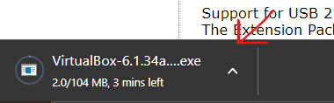

1. After the .exe file installed, click on it, and press next >> next >> next >> yes >> install
2. After it’s installed simply click finish

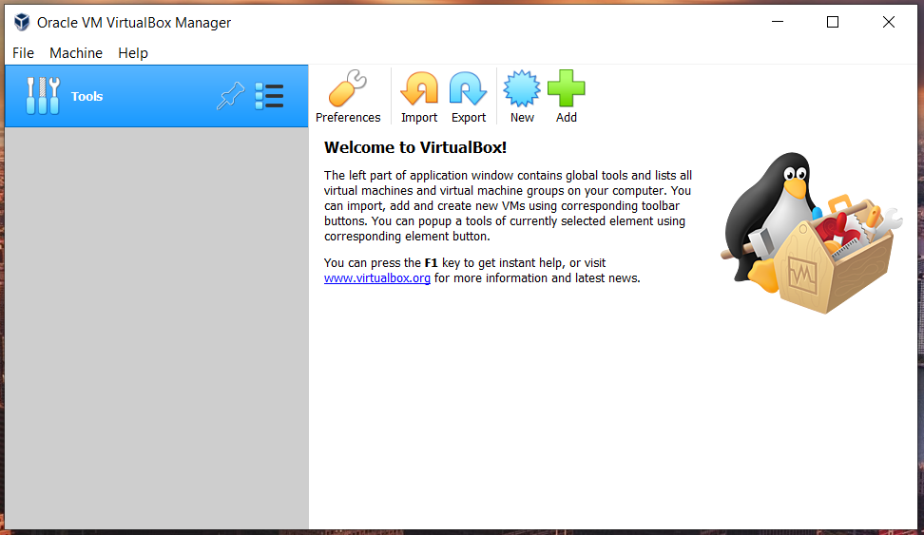

Step 2. Install Ubuntu

1. Go to the link <https://releases.ubuntu.com/20.04/> and click on “[64-bit PC (AMD64) desktop image](https://releases.ubuntu.com/20.04/ubuntu-20.04.4-desktop-amd64.iso)” to install the version 20.04

1. After the .exe file installed, go to the VB and click new and fill on the following information

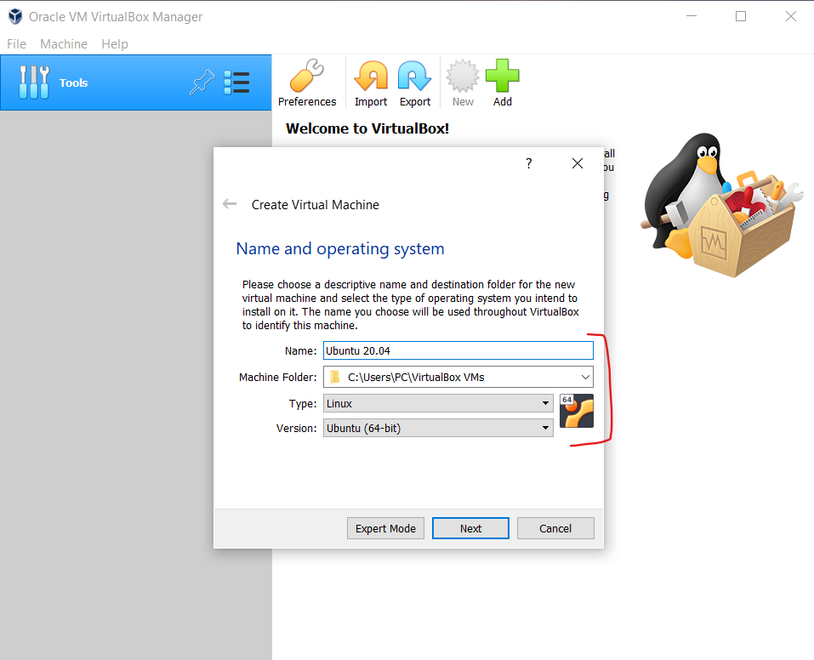

1. Then when this widow is open click install ubuntu

1. Then chose the English language and continue pressing next until the system installed

Step 3. Install ROS2 in Ubuntu

1. Open the terminal do the following

* Set Locale

* Setup Sources







* Install ROS2 packages







* Environment setup















Part 2, installing on Jetson nano

Rewrite the same above commands but on jetson nano and after test it using the following command

* ros2 topic list

**and finally, ROS2 has been installed Successfully**